**Problem Statement:**

● Use Hbase shell for performing the following operations

● Create the table customer with two column families

● Personal details and order details as column families. Create a unique number as row key (ssn/Aadhar no.,etc) Insert at least 10 records to each column Insert following values for personal details column family Name, age, city, state

● Insert following values for order details column family

● Order no., order quantity, and order amount

● Use put command to insert the values for each record. Use get command, to retrieve all the records of single customer.

**Solution:**

Creating table 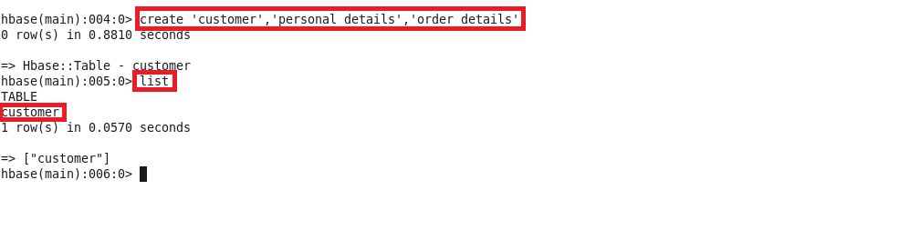

Inserting values for personal details column : family Name

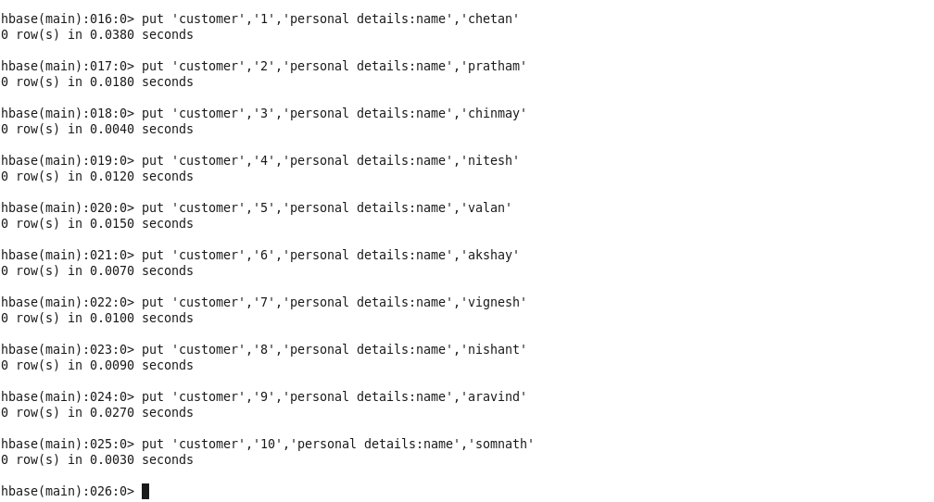

Inserting values for personal details column : age

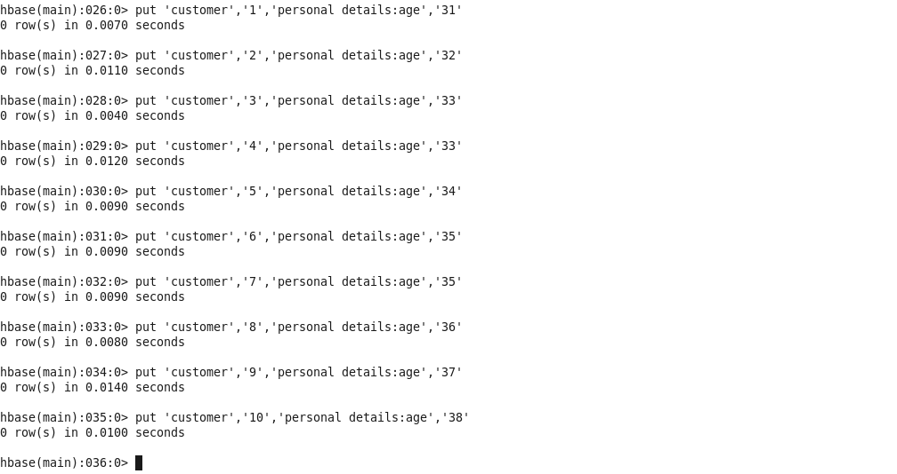

Inserting values for personal details column : city

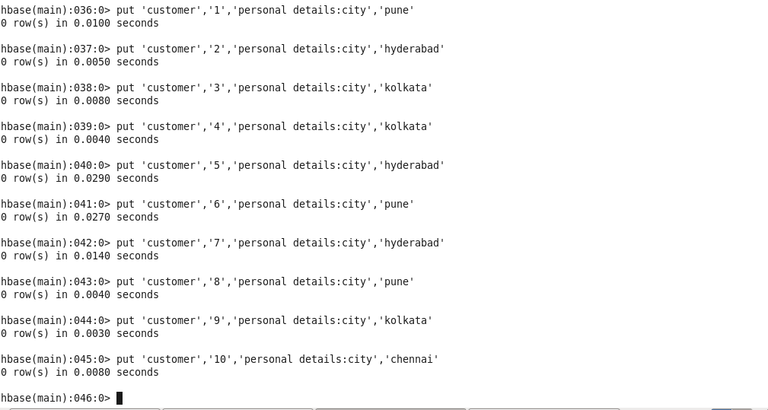

Inserting values for personal details column : state

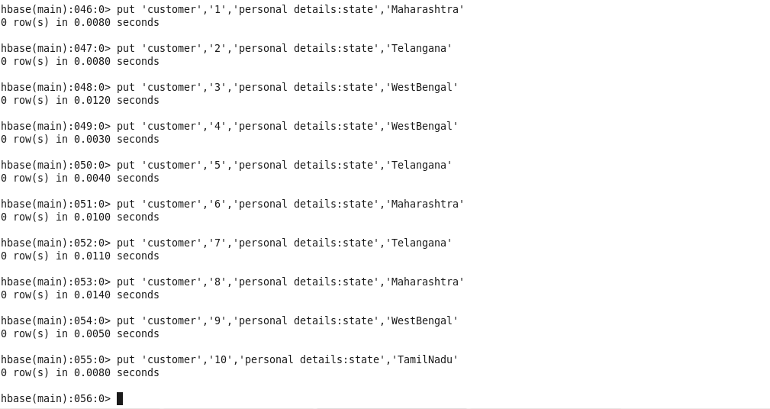

Inserting values for order details column : order no.

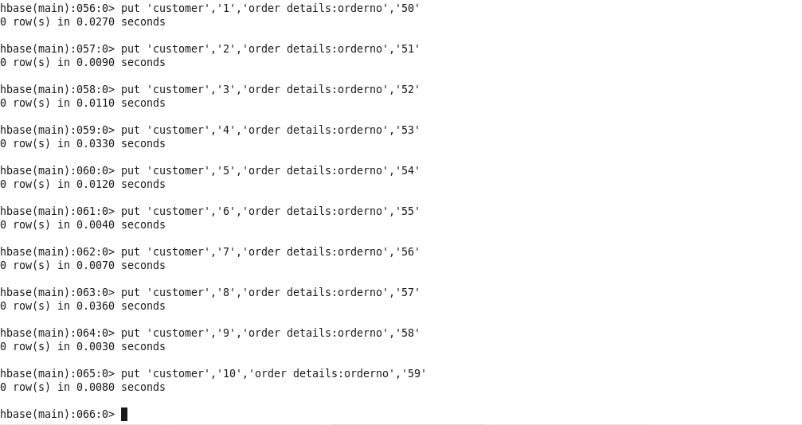

Inserting values for order details column : order quantity

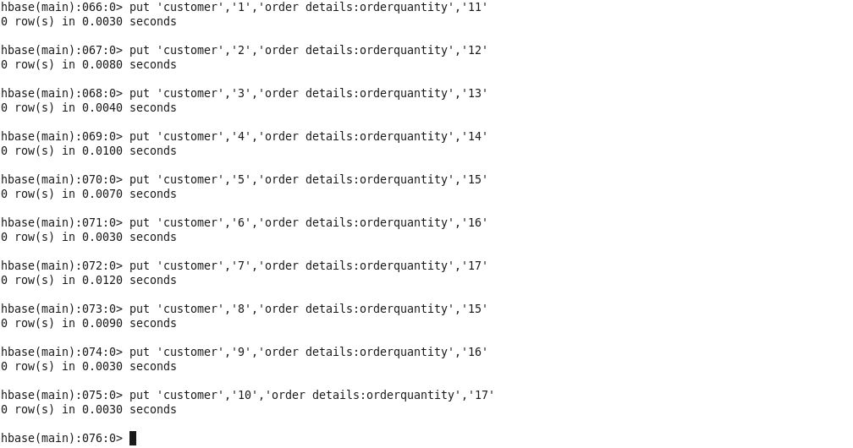

Inserting values for order details column : order amount

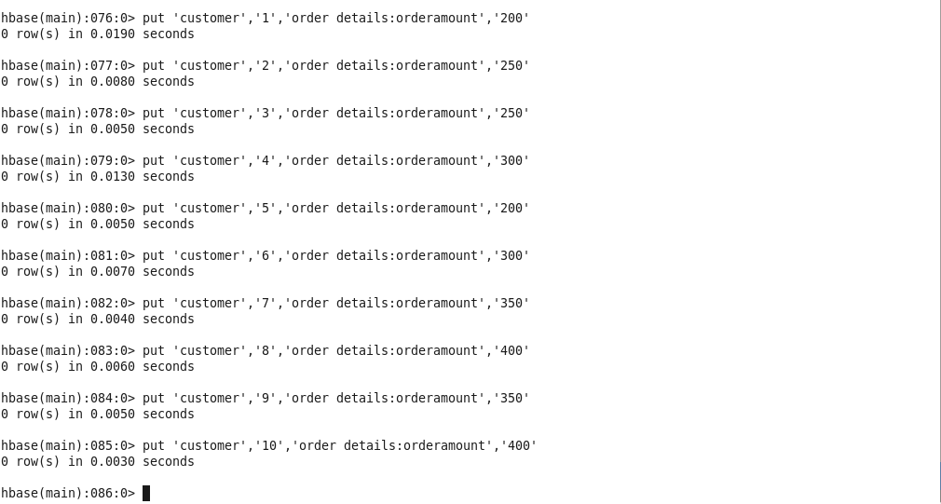

Using get command, we retrieve all the records of single customer

